*Quick Start Manual*

*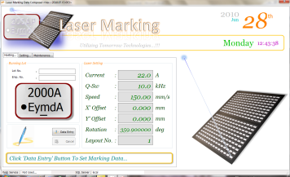--- Start Marking ---*

As what the User Interface had designed to serve better Quality of Usability. It provides a message showing what is needed to be done in order to prepare for a new marking.

As shown in the figure, click on the ‘Data Entry’ button. A wizard will pop-up and drive you through the Data Entry process.

1



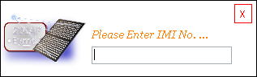

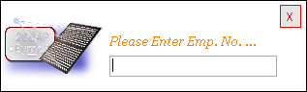

Anyhow, the ‘Data Entry’ process required 3 data that is the ‘Lot No.’, ‘IMI No.’ and the Employee No. The Employee No. is required on this version for generating traceable records. All the data can be enter via direct key-in using the keyboard or the using the Barcode scanner.

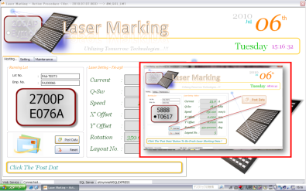When all the required data have been completely enter into the system. The system will make a request to the IIS server for a Marking Code. Once the request is responded by the server, the system will highlight what to do next as shown in the figure. Follow the instruction by clicking on the ‘Post Data’ button to transfer the Marking Data to the Laser Unit.

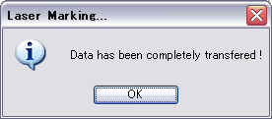A message will be shown once the data has been completely transferred to the Laser Unit which means the marking is ready to start. Press the ‘Start’ button to start marking.

*--- Important Message ---*

1. A Job-Setup must be carried out whenever the following condition had been done;
2. Mechanical Alignment
3. Laser Head Adjustment
4. Changes makes to the Marking Parameter / Profiles
5. Power Failure. The Server has to be turned <ON> first.
6. In order to confirm whether the server is up or not. Open the IE, and type the following address at the browser address bar.

*http://etmymnet/az_services/lmservices.asmx*

If the server is up, you should notice the following screen shot shown on your desktop.

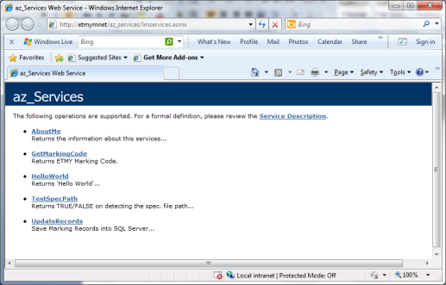

For any further technical assistance, kindly do not hesitate to refer to;

*Name : Mr. Zulhisham Tan*

*Mobile Phone : 019-2820574*

*eMail : zulhisham_tan@epsontoyocom.com*